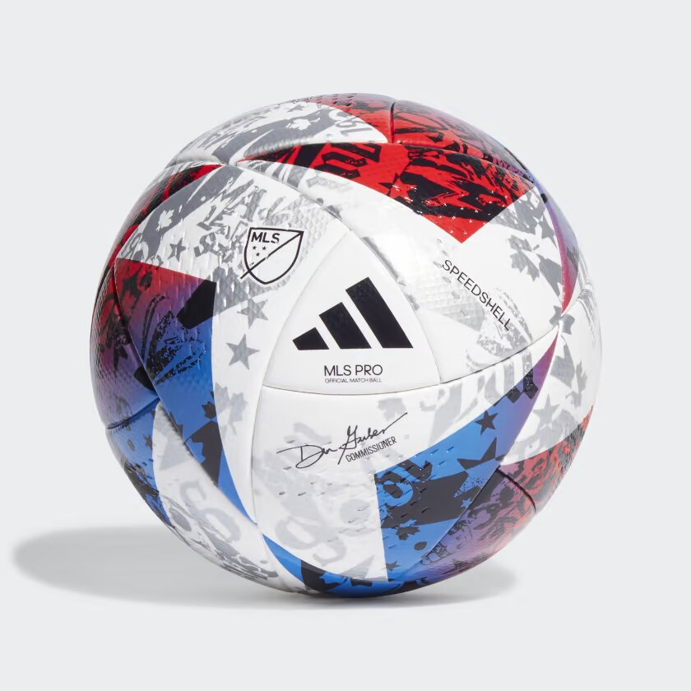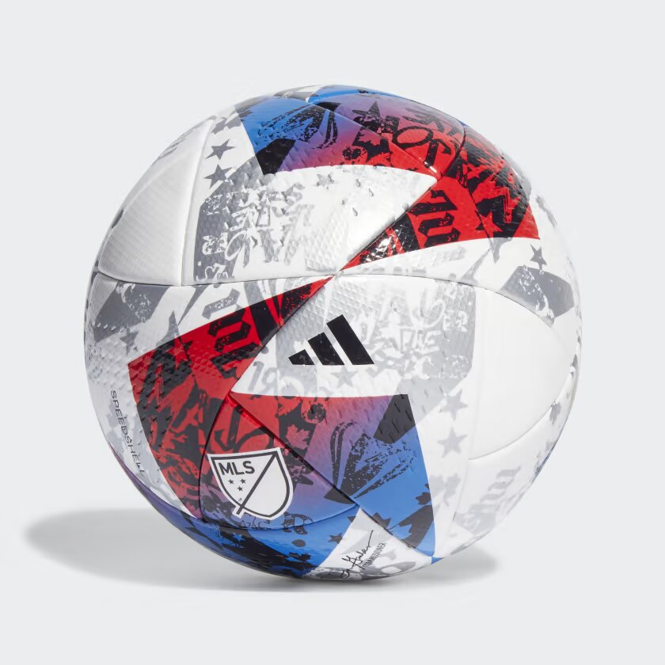

ADIDAS MLS PRO BALL

**THE SEAMLESS MATCH BALL USED IN MLS GAMES IN THE 23/24 SEASON.**

No sporting spectacle can beat soccer fans in full voice. Celebrating the songs and chants that bring MLS stadiums to life, this adidas ball gives off grungy vibes with music poster-inspired graphics. Beneath that dynamic design, the seamless, thermally bonded construction and butyl bladder ensure predictability and longevity. A FIFA Quality Pro stamp guarantees pitch-perfect performances.

**DETAILS:**

* 70% polyurethane, 20% recycled polyester, 10% viscose imitation leather
* High-grade butyl bladder
* Thermally bonded seamless construction
* FIFA Quality Pro certified
* Requires inflation
* Imported
* Product color: White / Blue / Red
* Product Code: HT9026